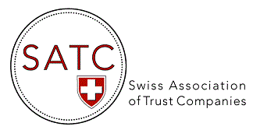

AGENDA 2024
Events & Webinars
DATE | TOPIC
19 March 2024 | Trust Accounting & Auditing Seminar organized & held in conjunction with STEP, Four Seasons Hotel de Bergues, Geneva
17-18 April 2024 | Roundtable on Cross-border planning series 2023 – Macfarlanes  (Geneva & Zürich) – registration with Macfarlanes
30 April 2024 | Webinar : Privacy Notice template for SATC Members (in the frame of the New Federal Act on Data Protection) with the collaboration of Schellenberg Wittmer and Alithis AG
22-23 May 2024 | Presence at the STEP Alpine Conference, Interlaken (as exhibitor)
6 June 2024 | 17th AGM of SATC, Hotel Beau-Rivage, Neuchâtel (in presence)
28 June 2024 | Webinar : Wecan Comply for Trustees focusing on the solutions for simplifying, streamlining and securing communications in the areas of KYC/Compliance & Audit, with the collaboration of Wecan Group
18 September 2024 | Trust Accounting & Auditing Seminar organized & held in conjunction with STEP (Credit Suisse Uetlibergstrasse 231, Zurich)
28 November 2024 | 17th EGM of SATC, by video conference (ZOOM)

